How to access Purple Mash at home.
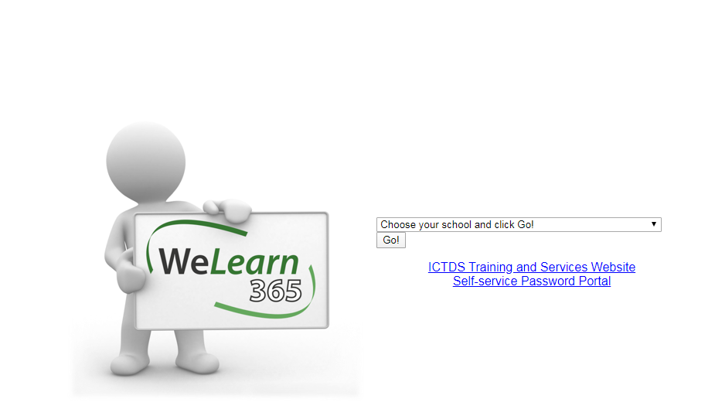
- www.welearn365.com

Select Kingsbury Primary School

- Log in with your child’s log on and password they use to access the computers at school. E.g jones.j9@welearn365.com

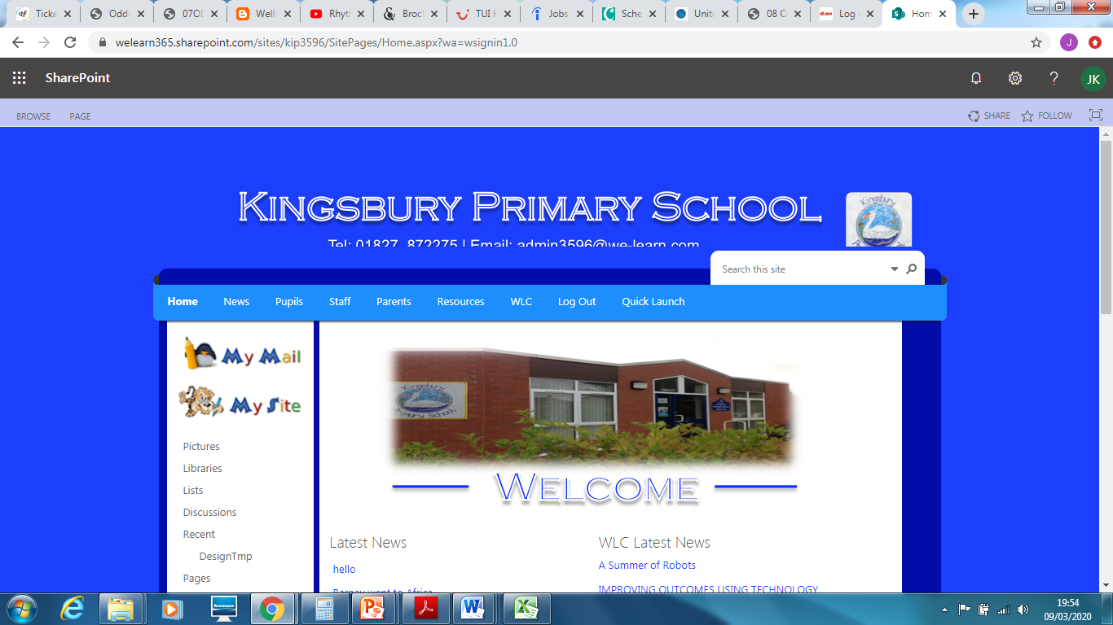

Click on Resources

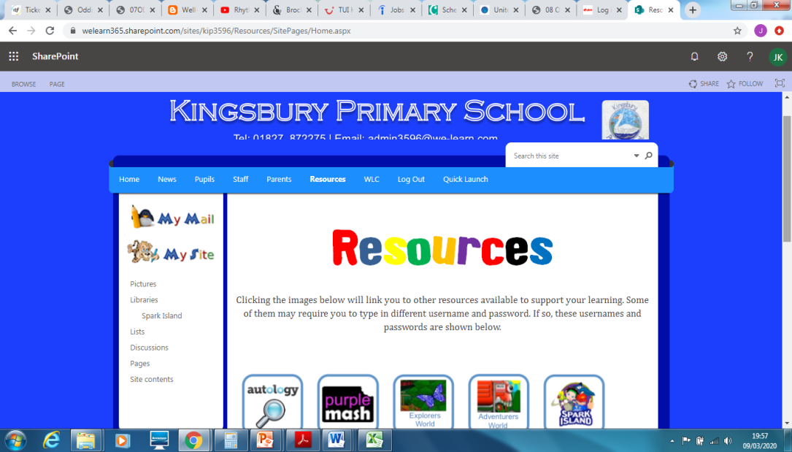

Select Purple Mash

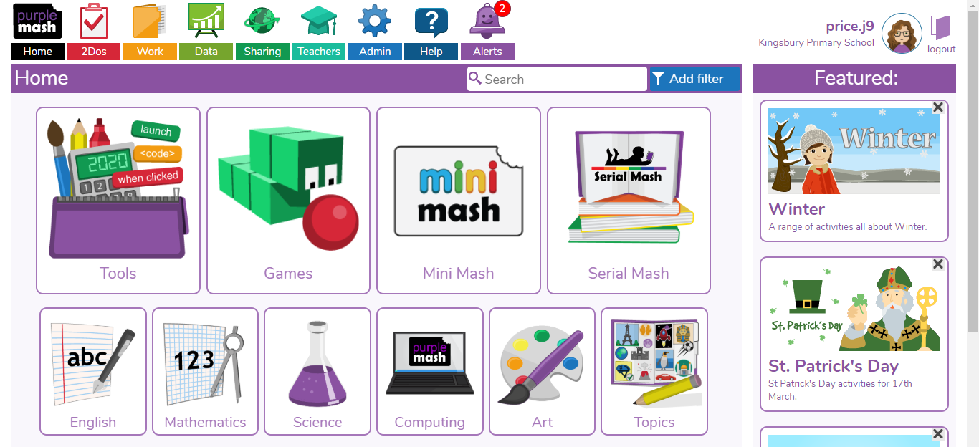
- Work set by your teacher can be found in the 2Do section.

Once work is completed, don’t forget to go back into the 2Do section and then hand in your work. This means your teacher will be able to look at and comment on your work.

