How to access Google Classroom

- classroom.google.com

- Log in with your child’s log on and password they use to access the computers at school. E.g jones.j9@welearn365.com.

- Click on your class to enter the classroom.
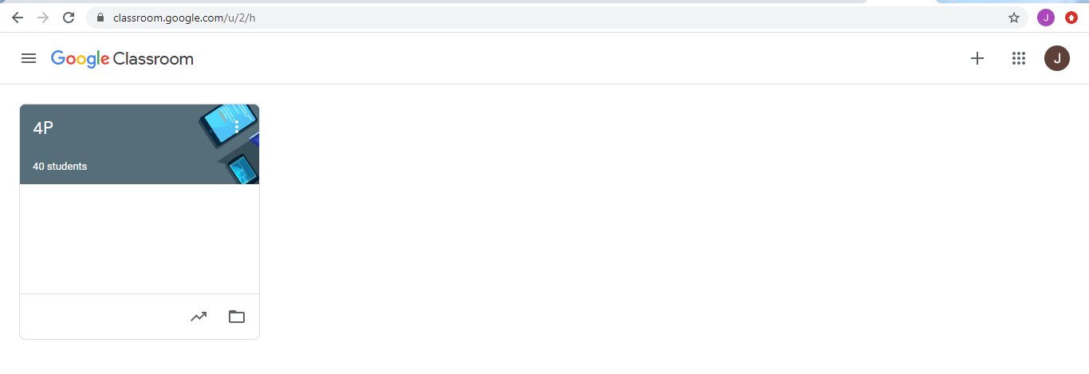
- You can access work from this page or from Classwork.
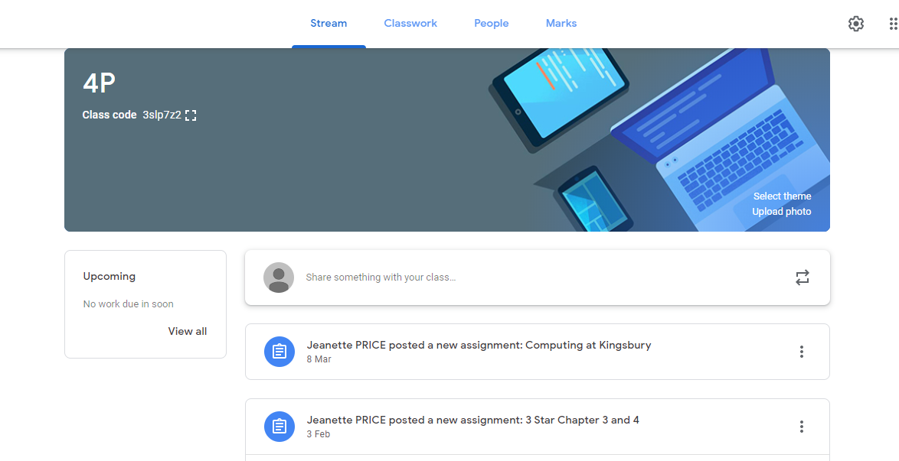

- Once work is completed, if they return to the main class page and select the work, there will be an option on the right hand side to hand in their work to their teacher. The will also be able to leave a comment if they want to!
Check back later to see if your teacher has left a comment for you.

