Computing Knowledge Organiser – Networks
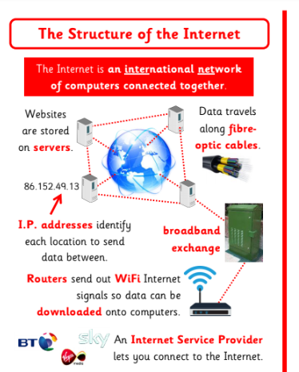
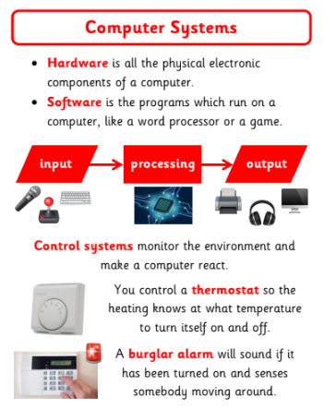
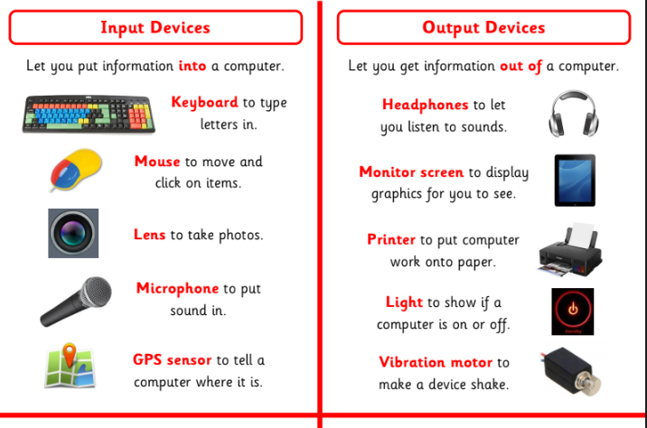
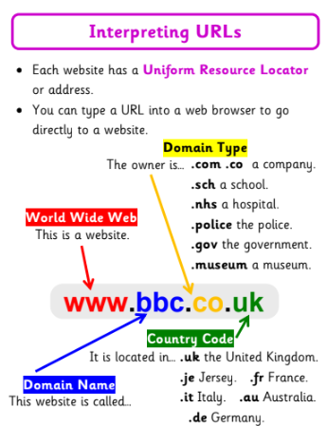

Key Knowledge
Server | A server is a powerful computer that often acts as a central hub for services in a network, (like a library) eg emails, internet access and file storage. Each computer connected to a server is called a client. Servers are left on at all times and are not used by individuals on a day-to-day basis.
Switch | A box that switches data from one computer to another. Schools can have lots  of switches. All wired computers connect back to the switch.
Wireless Access Point | A box that takes data from a wired network and converts it into wireless signals. Schools can have lots of WAPS or just one.
Router | A box that connects the schools’ network to the internet. There are millions of routers across the world.
Firewall | Software that tries to reduce the number of viruses that can come into the school network from the Internet.
Wired Network | These are wires that go from the switch to every wired computer. These are typically  much faster than wireless connections.
Wireless Network | Signals that pass through the air from the wireless access point to laptops or tablets.


